6A^{th} Grade: Unit 7, Lesson 7
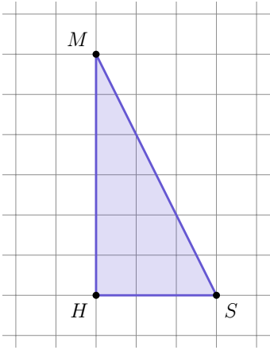
- Triangle MHS is shown in the figure. What is the height of the triangle MHS?

6 units

- A pentagon has been decomposed into the figures shown. What figures were made after the decomposition?
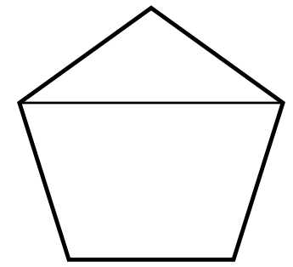

A triangle and a trapezoid

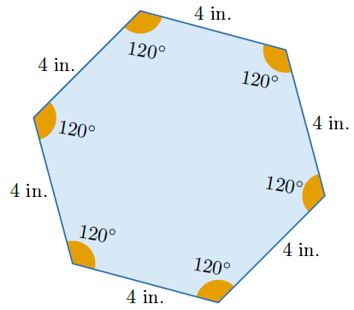
- A polygon with measurements in inches (in.) is shown. Why is this polygon a regular polygon?

The length of the sides are all the same and the measures of the angles are all the same.

